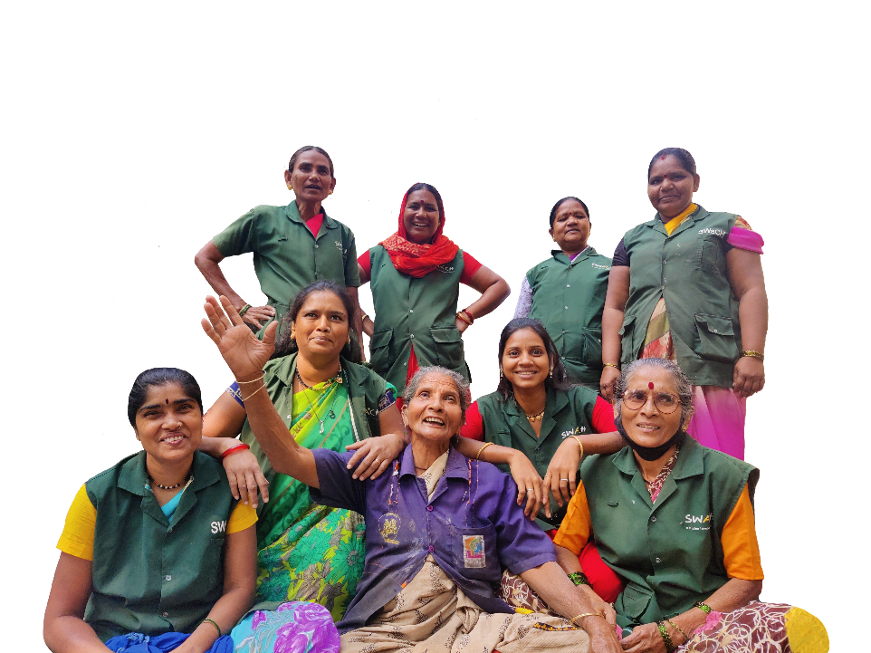**SWaCH Pune  
India’s largest waste picker cooperative**

Reg no. PNA/PNA(1)/GNL/(O)/1321/07-08

A joint initiative of the

PMC & KKPKP (Est. 2007)

**About SWaCH**

SWaCH is a story of transformation scripted by waste pickers against marginalisation and indignity of work. Through SWaCH, waste pickers have reclaimed their dignity and ensured their inclusion by building a sustainable, direct partnership with Pune Municipal Corporation for doorstep collection of waste. SWaCH Pune is a cooperative society, owned by waste pickers.

Today, **3,900+ waste picker members** of SWaCH provide daily doorstep waste collection service to more than **40 Lakh residents** of Pune. In the cooperative, each waste picker is an equal owner – participating in the governance of the cooperative, and is also a worker – responsible for providing a doorstep collection service to residents of Pune. Over the years, the model has evolved from waste collection into city-level zero waste solutions.

**Waste Collection**

For the last 17 years, SWaCH has been authorized as the central doorstep waste collection agency for Pune city. The work was specifically designed to enable participation of hitherto informal waste pickers (particularly women), generate the maximum number of livelihoods, and retain the entrepreneurial nature of waste picking work. For collecting **~16,000 tonnes of waste each day, SWaCH has 3,900 working members, 70% of whom are women**.

Each day, a SWaCH waste picker collects segregated waste from 200-250 houses using a non-motorized pushcart. Each waste picker has the right to reclaim recyclables from the dry waste and send these for recycling. In total, **SWaCH waste pickers recycle 200** **tonnes** of dry waste each day. Waste pickers are compensated for their work by citizens through user fees, and through the sale of recyclables. For 3-5 hours of work, a waste picker earns a total of Rs. 16,000 to 20,000 monthly. Waste pickers themselves have played an IEC role, leading to 98% source segregation in Pune.

**City-Scale Zero Waste Work**

Poorly managed wet waste is responsible for the majority of methane emissions from waste. Methane is 82x more potent than CO2 as a greenhouse gas. To choke the issue of wet waste at source, waste pickers have been upskilled to provide services for **in-situ** **composting and bio methanation. 160+ waste pickers are working across 250 sites** in Pune on wet waste.

Waste pickers have gone the extra mile to forge partnerships for typically non-recyclable wastes. Now, SWaCH waste pickers are playing a vital role in recycling multi-layered plastic (**MLP**), **thermocole**, rigid **plastics** and **sanitary** waste.

SWaCH also runs a **Reuse and Recycle centre** to collect old belongings from citizens and implement 3R principle at city level diverting 360 tons of old belongings into Reuse each year.

**Impact on Pune**

Annually, **SWaCH saves more than 120 crore rupees for the city** on processing, transportation and human resources. SWaCH waste pickers are conserving the environment of the city by diverting **over 200 metric tons of Dry Waste, 19 tonnes of wet waste and 10+ tonnes of plastics and other materials** away from landfills. As they reach every doorstep every day, they have forged long lasting relationships with citizens and have become a part of the citizen's pro-environment lifestyle.

**SWaCH Snapshot**

**Waste Collection**

* **Total Properties in Pune**: 14 Lakh (Including 23 new villages)
* **Covered By SWaCH Members**: 9.8 Lakh (1.8 L Slums)
* **SWaCH Coverage including new villages**: 68%
* **Coverage by others:** 22% PMC Ghantagadi, 9% Private, 1% Uncovered
* **Recycling Impact:** 227 Ton per day (82,891 Tonnes per annum)

**Costs & Benefits**

* **Cost to Corporation:** 15.23 Cr p.a.
  + 6.23 Cr Administrative Cost
  + 2 Cr Equipment and PPE for waste pickers
  + 6 Cr Slum Subsidy to waste pickers
  + 1 Cr Social Welfare schemes for waste pickers
* **Financial Savings to Corporation: 113 Cr Annually** 
  + **21 Cr** through waste **diversion**
  + **92 Cr** in manpower costs (vs. 80 Cr user fees received by waste-pickers)

**User Fees:**

* **~95 - 98% Recovery in areas covered by SWaCH Waste-pickers**
* **PMC’s Property Tax recovery rate of 74% (of which slum is 0%)**
* Out of the properties paying Swach waste-pickers, 17% (1.7L properties) are slum dwellings

**Terms of Service to Citizens:**

* 77% of Pune citizens receive user-fee based waste collection service – 68% by Swach members, 9% by private operators
* 21% receive service from PMC’s Ghanta-gadis *without user-fees / cost*

**Demographics and Income**

**SWaCH Members**: **3,900+** [SC / ST: 93%]

**Women:** 70% (Large section of single, widowed, abandoned and old women, including single mothers, and women taking care of grandchildren)

**Age:** 33% (20 – 40); 51% (40 – 60); 16% (60-65)

**Working Hours:** *Mornings or Evenings – 3 to 6 hours, flexible* as per individual capacity & local needs. Allows for maximum integration of women, single mothers and elderly.

**Ownership & Governance**: Each member is a shareholder and equal owner. Members elect 180 representatives and 14 board members for governance.

**Income:**

1. **User Fees (2024)**: Rs. 85 / household, Rs. 65 / Slum Household, Rs. 170 per shop
2. **Sale of Scrap:** ~ 20-30% of total income
3. **Average income** pro-rata equal to or higher than minimum wages [~18,000 for 3 - 5 hours of work vs. 20,000 Minimum Wage for 8 hours]

**Recycling**

**Dry Waste recycled:** 200 Tonnes per day

**Innovations in 3R**: 30 Tonnes per day

* Self-sustainable Reusables Thrift Store (V Collect): 3 TPD
* In-situ Composting & Biogas (230 premises): 19 TPD
* EPR Based MLP Recycling (ITC Ltd.): 4 TPD
* EPR Based Thermocole Recycling (KK Nag): 100 Kg per day
* Wet waste to animal feed: 1 TPD
* Sanitary Waste: 3 TPD

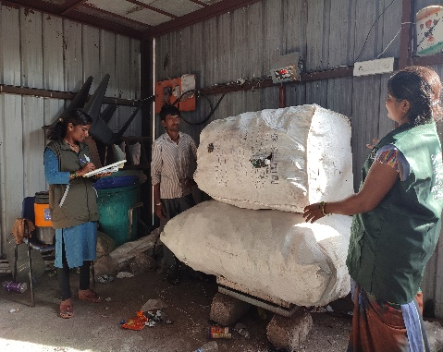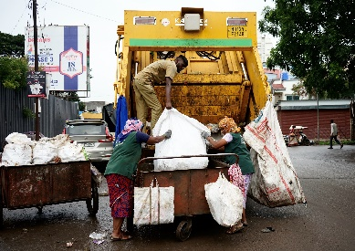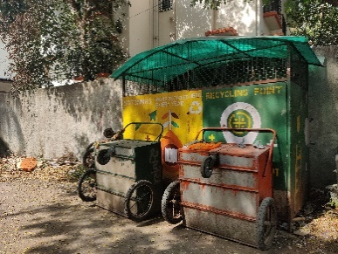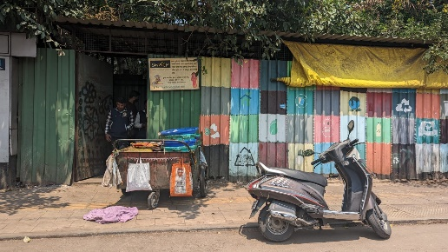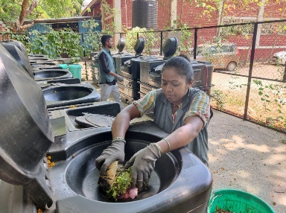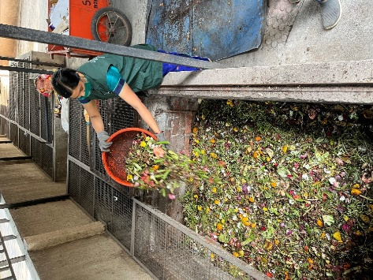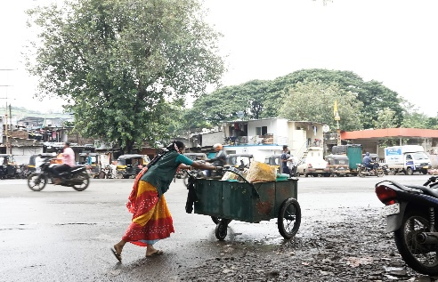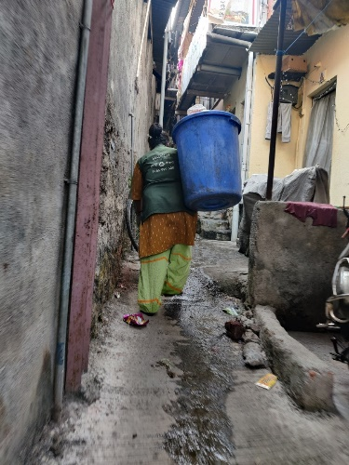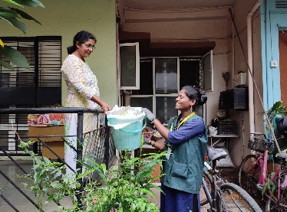

**True Door Step Collection: Driven by Women & Fueled by Recycling**

4 (300 WP)

Coop Scrap Store

In situ composting

230 sites (17 TPD)

64 + 300

9.8 L (1.8 Slum)

2500 Pushcarts,

250 Tempos

Vehicles

Coverage

Feeder Points

900

Sheds & Pinjras

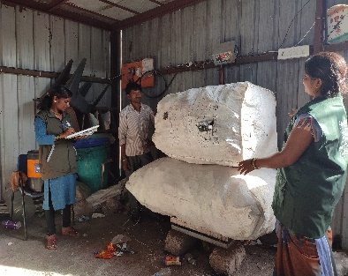

SWaCH Model Beyond Waste Collection

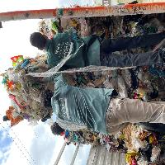

**300 waste pickers**

**6 TPD**

**Cooperative scrap shops**

**1 TPD**

**160+ waste pickers**

**19 TPD**

**RRR** **initiative with citizens**

**In-situ composting and biogas by waste pickers**

**Recycling the non-recyclable**

30+ tons per day handed by SWaCH-linked initiatives

Income and livelihoods for 1,000+ waste pickers

New initiatives – Grains, Old Clothes, Hair

**3 TPD**

**.1 TPD**

**EPR for Thermocole**

**Sanitary collection for recycling**

**EPR for multi-layered plastic**

**700 waste pickers**

**4 TPD**

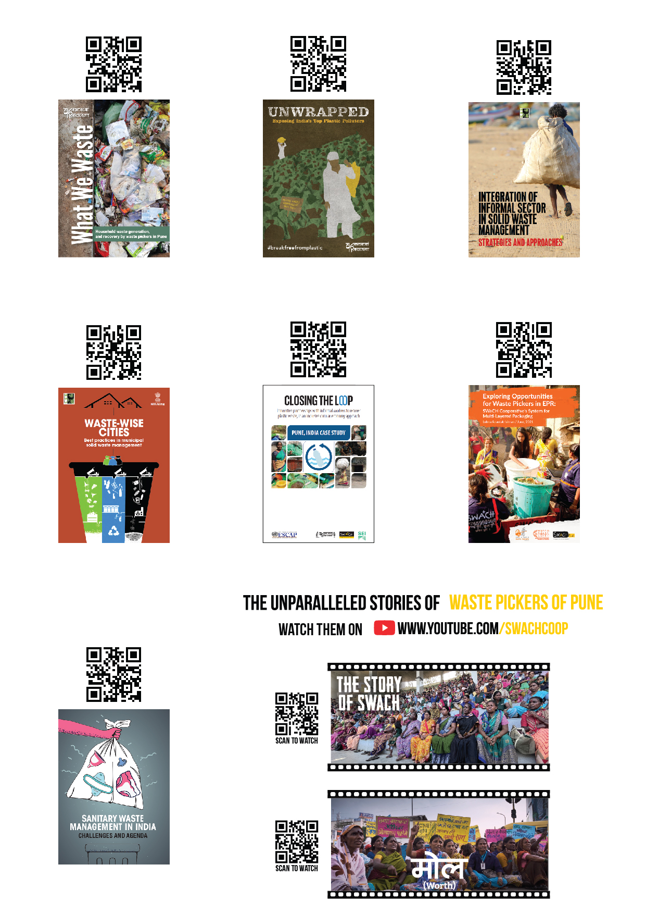

**Scan to read more about SWaCH**